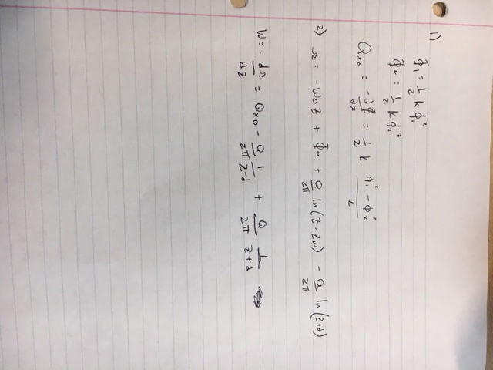

Flownets:

a= 0.6

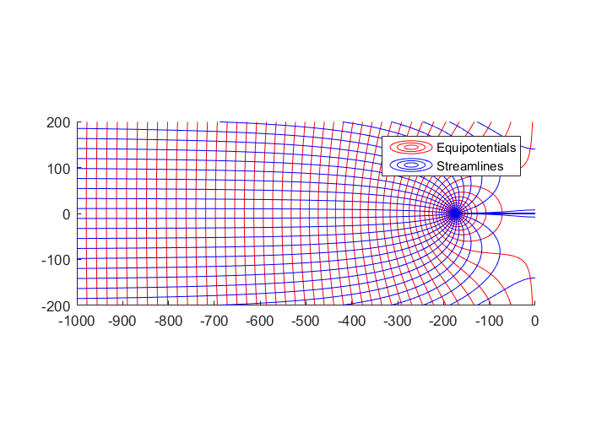

a= 1.0

C:\Users\Jack\AppData\Local\Microsoft\Windows\INetCache\Content.Word\flow_net_a=1.tif

a= 1.5

C:\Users\Jack\AppData\Local\Microsoft\Windows\INetCache\Content.Word\flow_net_a=1.5.tif

W:

a=0.6

C:\Users\Jack\AppData\Local\Microsoft\Windows\INetCache\Content.Word\modulo_W_a=1.tif

a=1.0

C:\Users\Jack\AppData\Local\Microsoft\Windows\INetCache\Content.Word\modulo_W_a=1.5.tif

a= 1.5

C:\Users\Jack\AppData\Local\Microsoft\Windows\INetCache\Content.Word\modulo_W_a=.6.tif